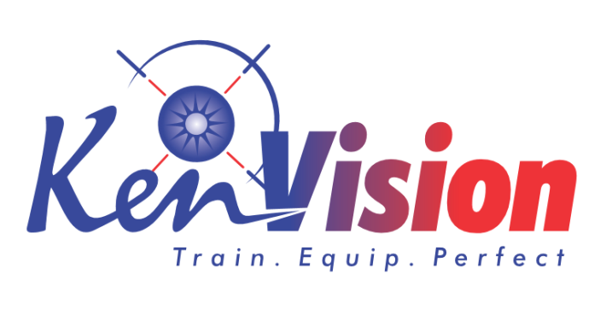 | KENVISION TECHNIKS LTD  TRAINING DIVISION  JAN 2023- DEC 2023 | FOR OFFICIAL USE ONLY  CONFIRMED  REGISTERED  (ON TRACK)
WORKSHOP ENROLLMENT REQUEST FORM 2023
1. WORKSHOP (One form for each workshop)
Workshop Title | Workshop Date
2. PARTICIPANT INFORMATION
Participant’s Name | Job Title
Education Level: | Grade:
Related Work Experience | Period:
Work Phone | E-Mail
Fax (Optional) | First Time Trainee at Kenvision Techniks  Kenvision Techniks Alumni
Self-Sponsored | Sponsored (Name of your sponsor) ______________________________________
3. ATTENDANCE MODE
In-Person ( Class/ workshop) | Online – Provide us with your address for invoicing purposes
Phone | E-Mail
4. PAYMENT INFORMATION
EFT to Kenvision Techniks Account  KENVISION TECHNIKS LTD  A/C NO:0010291172443  EQUITY BANK-FOUR WAY TOWERS,MUINDI MBINGU STREET:  Cash paid to office | Paypal (Online)  Mpesa to 0725 579251  Direct deposit to: KENVISION TECHNIKS LTD  A/C NO:0010291172443 EQUITY BANK

5. IMPORTANT INFORMATION
Enrollments are on a first-come/first-served basis. You will receive an e-mail confirmation if you are enrolled in the workshop. Do not attend the workshop if you do not receive an e-mail confirmation. All confirmations are sent to the participant and a copy of the same is maintained in our systems. If you want to modify this procedure, please note it here.
Standard terms and conditions
- Workshop fees quoted are for each individual delegate
- Registration for the training must be finalized with Kenvision Techniks five days before the date of the course.
- Unless otherwise stated, the training normally starts at 8.30am and finish at 4.00pm
- Hotel Venue- based training fee shall cover/. tuition, course notes/or text, tea/coffee in the midmorning and mid-afternoon breaks, mineral water and lunch meal
- Travel and any possible accommodation are not included in the fees. They are the responsibility of the delegate
- Whilst every effort is made to ensure that advance publicity is correct, Kenvision Techniks Ltd reserves the right to make changes to program details or other requirements which might be necessary
- If a booking is cancelled more than 10 working days before the course date, any fees paid will be refunded, although an administration fee of 20% will be charged. If a fee is cancelled 10 working days or less, then the full course fee is payable and no refund will be given
- Delegate substitution from the same organization may be made without charge, although notification of the change should be given to Kenvision Techniks Ltd a minimum of 3 working days prior to the date of the course
- Courses are run subject to a minimum number of delegates attending each course. If it becomes necessary for Kenvision Techniks to cancel a course, any fees paid shall be refunded in full. In such a case, Kenvision Techniks Ltd’s liability shall be limited to the refund of the course fee.
- Delegates attend the course at their own risk. Kenvision Techniks accepts no liability for any loss, damage or injury suffered by any delegate.

I agree to and accept the terms and conditions set above:

Signed Date

6. E-MAIL FILLED FORM OR DELIVER IT TO:

E-Mail forms to: ken_trainers@kenvisiontechniks.com .  You can also the form to +254731983371 | Interoffice: Courier Service delivery: Building Feliz Stalls Q7,8,& 9 Breaking News St, Kahawa Sukari Ave, Kahawa Sukari, Nairobi - Training Division
7. INFORMATION
Please call Kenvision Techniks (+254-725-579 251) if you have any questions regarding our Workshops. Kenvision Techniks Workshops Schedules and Enrollment Forms are available at www.kenvisiontechniks.com

